Factory - MySQL
Info-Gathering
of Azure Database for
MySQL - Single Server /
On-Premises / Azure VM / Other Cloud MySQL workload to Azure Database for MySQL - Flexible Server - User Guide



Disclaimer: These scripts are intended for use of Info Gather Assessment utility and do not interact with the user databases or gather any sensitive information (e.g. passwords, PI data etc.). These scripts are provided as-is to merely capture metadata information ONLY. While every effort has been made to ensure accuracy and reliability of the scripts, it is recommended to review and test them in a non-production environment before deploying them in a production environment. It is important to note that these scripts should be modified with the consultation of Microsoft.
Document Summary

Document Item | Current Value
Document Title | Factory - MySQL Info-Gathering of Azure Database for MySQL – Single Server / On-Premises / Azure VM / Other Cloud MySQL workload to Azure Database for MySQL - Flexible Server - User Guide
Program | Cloud Accelerate Factory
Date Last Modified | 22-Apr-2024
Date Last Reviewed | 22-Apr-2024
Status | Completed
Document Description | This document provides the procedure/steps to execute the Automation script which gathers the MySQL server details from Azure, Windows, and Linux environment.

Revision History

This section represents the change history of the document. Revisions of the document must be tracked by identifying a new version number, the date it was modified, the person making the change, and the reason for the change.

Date | Version | Change Description | Author | Reviewer
22-Apr-2024 | 1.0 | Initial draft | Chethan, Mukesh, Arun | Rackimuthu Kandaswamy, Sharad Khadtare

Table of Contents
1 Objective 5
2 Roles and Responsibilities 5
3 Prerequisites for MySQL Server Info gathering script execution 5
3.1 Operating System Requirements 5
3.2 Software requirements 5
4 Procedure 6
4.1 MySQL Info-Gathering on Windows Server 6
4.1.1 Azure Database for MySQL - Single Server Info-Gathering (Factory-MySQL-CLI-Windows.ps1) 6
4.1.2 MySQL Server Info-Gathering (Factory-MySQL-Windows.ps1) 10
4.2 MySQL Server Info-Gathering on Linux Server 14
4.2.1 Azure Database for MySQL - Single Server Info-Gathering (Factory-MySQL-CLI-Linux.ps1) 14
4.2.2 MySQL Server Info-Gathering (Factory-MySQL-Linux.ps1) 17
4.3 MySQL Server Info-Gathering using Azure Cloud Shell 21
4.3.1 Scripts Folder 22
4.3.2 Preparing the INPUT File (Azure_Subscription.csv) 23
4.3.3 Script execution (Factory-MySQL-CLI-Linux.ps1) 23
5 Appendix. 27
5.1 Checking error logs 27
5.2 Troubleshooting 27
5.3 Input CSV file- Azure_Subscription.csv 28
5.4 Input CSV file - Factory-MySQL_Server_Input_file.csv 29
5.5 Internet access to the URLs below: 30
5.6 Without Internet access to the URLs 31
5.7 Installing Azure CLI for Windows and Linux 31
5.8 PowerShell Version, Modules & Execution policy 31
5.9 PowerShell Installation on Linux 32
5.10 Adding mysql as an environment variable in Windows 32
5.11 Adding Azure CLI as an environment variable in Windows 35

Objective
This document provides the procedure/steps to execute the Automation script
(Factory-MySQL-CLI-Windows.ps1, Factory-MySQL-CLI-Linux.ps1, Factory-MySQL-Windows.ps1,
Factory-MySQL-Linux.ps1) which gathers the MySQL Server details from Azure, Windows, and Linux environment.

Note: The Automation Scripts does not fetch/access any of the user database data. The values present in the Screenshots are demo values. Please change the values as Appropriate.

Roles and Responsibilities
Task | Responsible | Accountable | Consulted | Informed
Info-Gather | Customer/Factory | PM | Factory | PM/Factory

Prerequisites for MySQL Server Info gathering script execution

Operating System Requirements
- Supported Operating System
  - Windows 10, Windows Server 2012, Windows Server 2012 R2 and above
  - Linux - RHEL v7 & above, Ubuntu v14 & above

Software requirements
- MySQL Client 5.6 and above
- Azure CLI (To gather Azure Database for MySQL single server metadata)
- PowerShell 5.1 and above.

Procedure

MySQL Info-Gathering on Windows Server

Azure Database for MySQL - Single Server Info-Gathering
(Factory-MySQL-CLI-Windows.ps1)

Scripts Folder
- Unzip the MySQL-Info-Gather zip file received by Factory team.

Preparing the INPUT CSV File - Azure_Subscription.csv
- In order to support the Info Gathering process, INPUT CSV FILE (Azure_Subscription.csv) should be provided with Azure Subscription data.
- Each column will represent an Azure Subscription detail for Azure MySQL Single Server Info Gathering
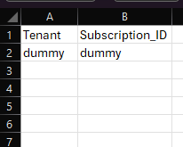

Script execution (Factory-MySQL-CLI-Windows.ps1)
- Open windows Command prompt as Administrator
- Change the working directory/folder to the folder MySQL-Info-Gather where the scripts are present.
- Enter the following command at the windows command prompt to execute the info-gather script.

Powershell.exe -ExecutionPolicy Bypass -File .\Factory-MySQL-CLI-Windows.ps1

Create support folders (Logs, Output, Downloads etc)
- After triggering the automation all the support folders (Logs, Output, Download etc.) will be created automatically by the automation script in the MySQL-Info-Gather folder

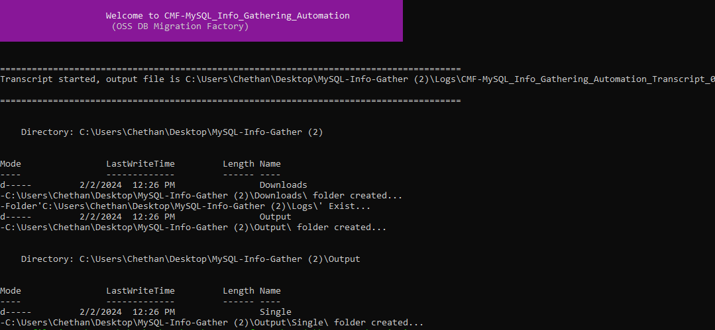

Validate Azure CLI
- Automation script validates if the Azure CLI application is installed. If it is not installed, you will have to install it manually via a link provided on the output screen.
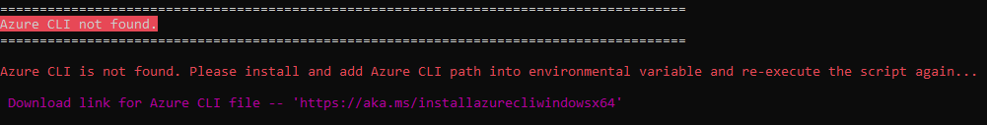
- Once Azure CLI Installation is complete, ensure the installation path is added to the environmental variables. Kindly close the Command Prompt and validate Azure CLI by re-running the automation script again.
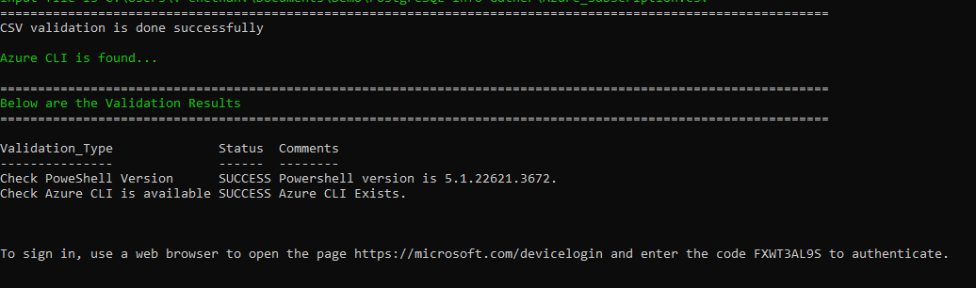
- PowerShell version and Azure CLI are validated successfully.

Azure Portal authentication
- Automation requires the Azure portal authentication. Use the provided URL and code to authenticate

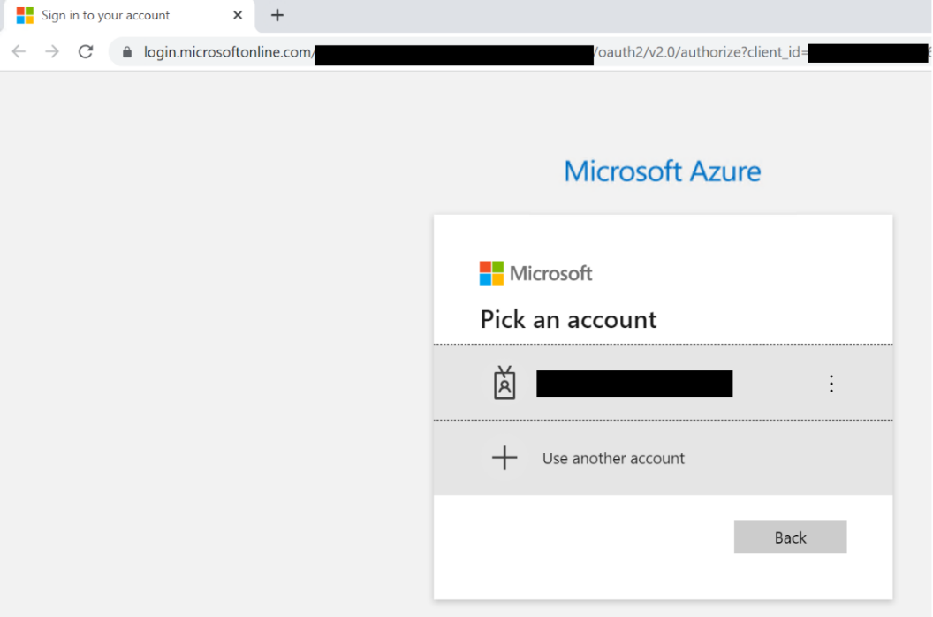

Export Info-Gathering details and generating JSON files.
- Once Azure portal authentication is successful, Automation gathers MySQL Single server details to update them in csv files. Also, Azure MySQL CLI’s commands output will be exported to JSON files.
- The JSON files can be found in the Folder Output Single.

Azure MySQL Single Server JSON output
- The Following JSON output file will be generated and contains the list of all Azure MySQL Single Server from the given Azure subscription(s).
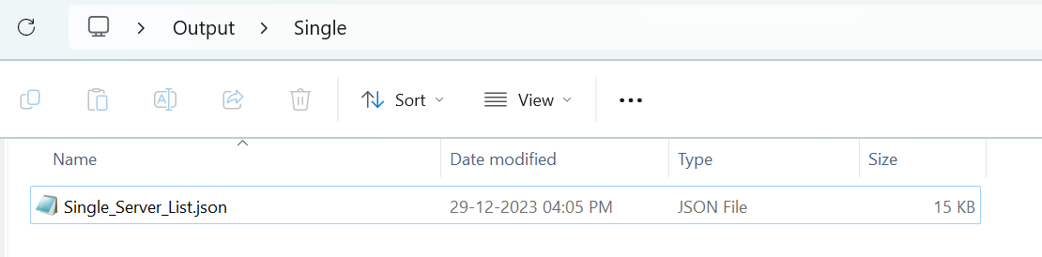

Azure MySQL Single Server CSV output
- CSV files will be generated for all the MySQL Single Server/Instance(s) from the given Azure subscription. Azure CLI’s output is as follows.
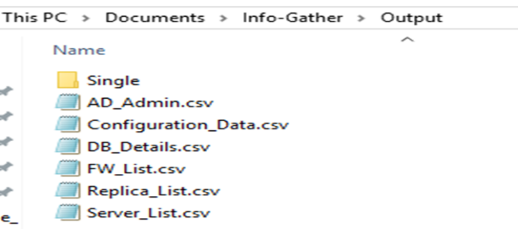
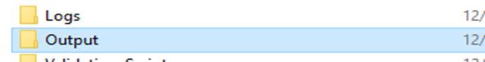

Automation Script Transcript Log
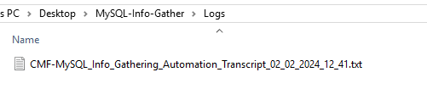
Note: For the Automation, transcript will be generated in text format as shown above

MySQL Server Info-Gathering (Factory-MySQL-Windows.ps1)

Scripts Folder
- Unzip the MySQL-Info-Gather zip file received by Factory team.

Preparing the INPUT CSV file
(Factory-MySQL_Server_Input_file.csv)
- To support the Info Gathering process, INPUT CSV FILE
(Factory-MySQL_Server_Input_file.csv) should be provided with MySQL Server details.
- Provide the Mandatory fields highlighted in red color.
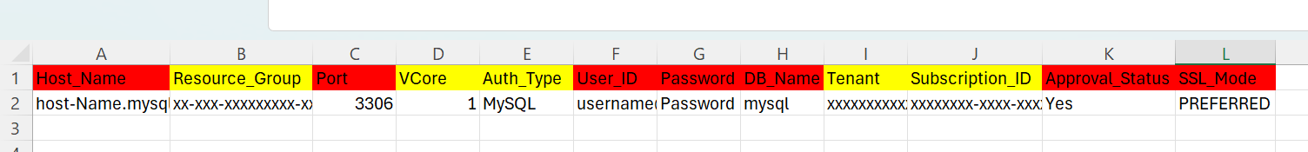

Script execution (Factory-MySQL-Windows.ps1)
- Open windows Command prompt as Administrator
- Change the working directory/folder to the folder MySQL-Info-Gather where the scripts are present.
- Enter the following command at the windows command prompt.
Powershell.exe -ExecutionPolicy Bypass -File .\Factory-MySQL-Windows.ps1
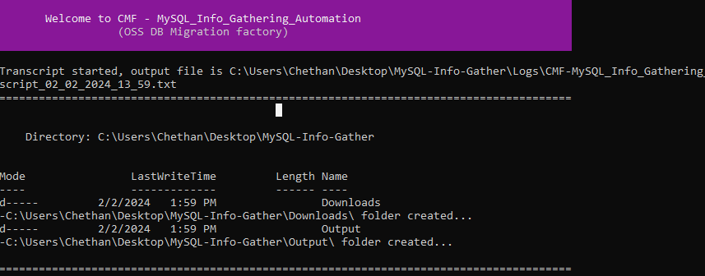
Note: After triggering the automation all the support folders (Logs, Output, Downloads etc.) will be created automatically by the automation script, MySQL path is validated, and it will ask user to proceed with the execution of the script.
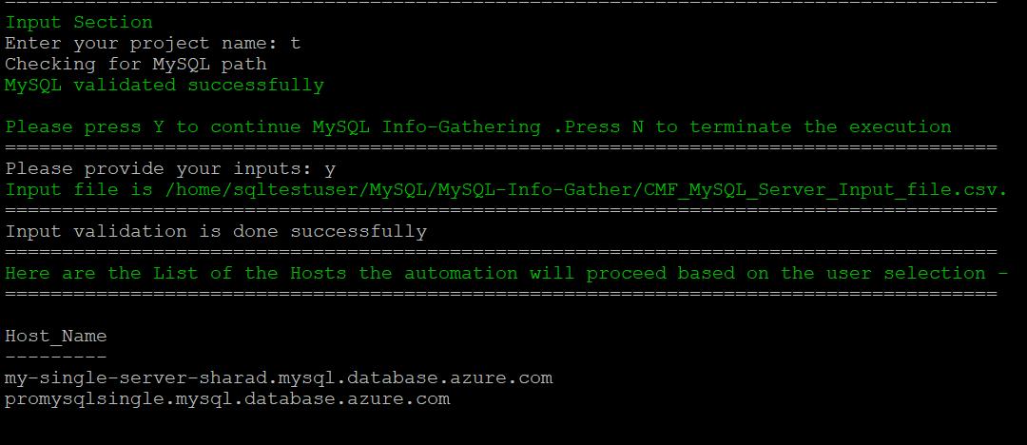
- The script then Validates the list of approved Hosts to proceed with execution. Continue by Entering “Y” and provide your Project Name. You’ll get below final status of the script execution.
- Please Enter “Y” to perform Info Gathering of Hosts above, otherwise Enter ‘N’ to terminate the execution.
Note: Ensure you add the location of psql.exe to your Path environment variables
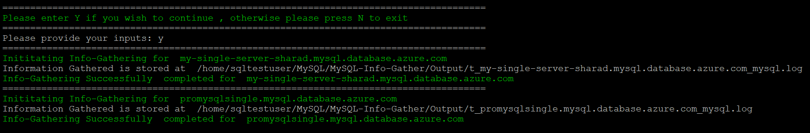
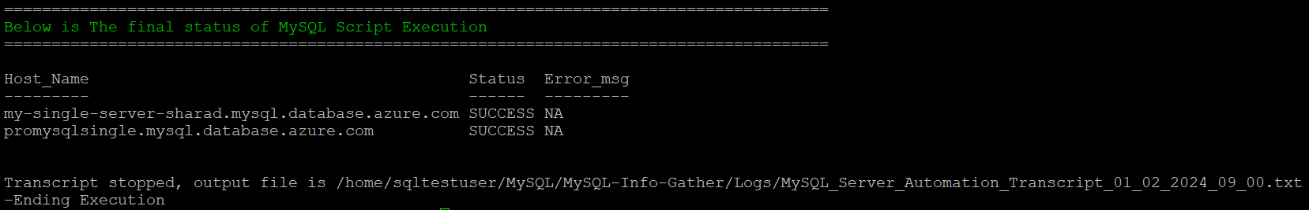

Export Info-Gathering details and generating output log files.
- Output log files are generated for each MySQL Server as shown in the Output Folder below.
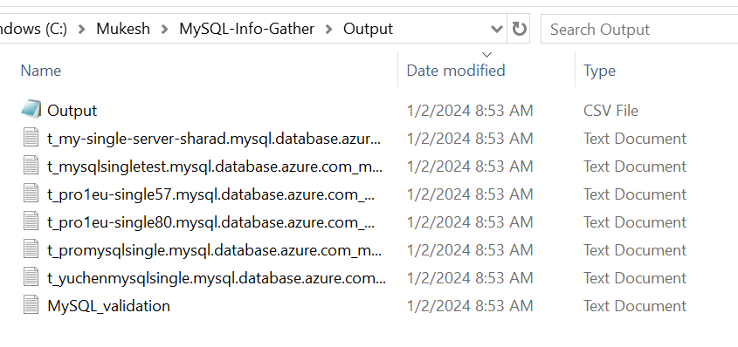

Automation Script Transcript Log
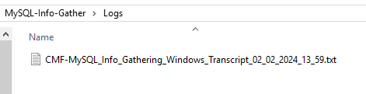
Note: For the Automation, transcript will be generated in text format as shown above
Note:
- Output files generated using Factory-MySQL-CLI-Windows.ps1 and the log files generated by Factory-MySQL-Windows.ps1 will be in the same Output and Logs folder.
- Please share compressed Output & Logs folder with Factory Team.

MySQL Server Info-Gathering on Linux Server

Azure Database for MySQL - Single Server Info-Gathering
(Factory-MySQL-CLI-Linux.ps1)

Scripts Folder
- Unzip the MySQL-Info-Gather zip file received by Factory Team
Commands: unzip MySQL-Info-Gather.zip
cd MySQL-Info-Gather /
ls -lrt
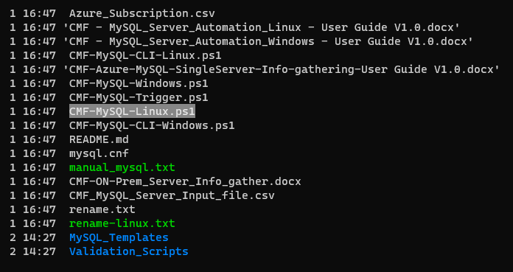

Preparing the INPUT CSV File - Azure_Subscription.csv
- To support the Info Gathering process, INPUT CSV FILE (Azure_Subscription.csv) should be provided with Azure Subscription data.
- Each column will represent an Azure Subscription detail for Azure MySQL Single Server Info Gathering
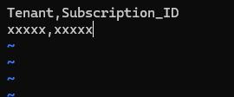

Script Execution
- Open Terminal window
- Change the working directory/folder to the folder MySQL-Info-Gather where the scripts are present.
- Enter the following command in the terminal to execute the info-gather script.
For Linux:
pwsh ./Factory-MySQL-CLI-Linux.ps1

Create support folders (Logs, Output, Downloads etc)
- After triggering the automation all the support folders (Logs, Output, Download etc.) will be created automatically by the automation script in the MySQL-Info-Gather folder
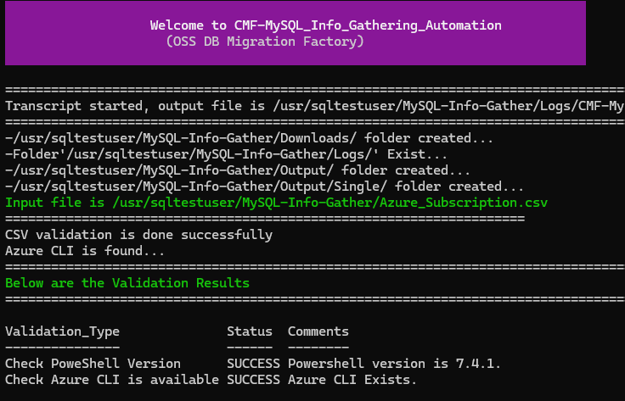
- PowerShell version and Azure CLI are validated.
- Automation script validates if the Azure CLI application is installed. If it is not installed, you will have to install it manually via a link provided on the output screen.
- Automation requires the Azure portal authentication
- Copy the device login URL and code to authenticate

Export Info-Gathering details and generating JSON files
- Once Azure portal authentication is successful, Automation gathers Azure MySQL Single Server details to update them in csv files. Also, Azure CLI’s MySQL commands output will be exported to JSON file.
- The JSON files can be found in the Folder Output Single

Azure MySQL Single Server JSON output
- The Following JSON output file will be generated and contains the list of all Azure MySQL Single Server from the given Azure subscription.
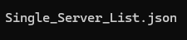

Azure MySQL Single Server CSV output
- CSV files will be generated for all the MySQL Single Server/Instance(s) from the given Azure subscription. Azure CLI’s output are as follows,
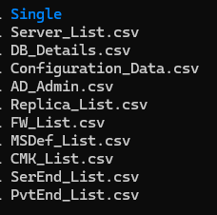

Automation Script Transcript Log
Note: For the Automation, transcript will be generated in text format as shown above

MySQL Server Info-Gathering (Factory-MySQL-Linux.ps1)

Script Folder
- Unzip the MySQL-Info-Gather zip file received by Factory Team
Commands: unzip MySQL-Info-Gather.zip
cd MySQL-Info-Gather/
ls -lrt

Preparing the INPUT CSV file -
(Factory-MySQL_Server_Input_file.csv)
- To support the Info Gathering process, INPUT CSV FILE
(Factory-MySQL_Server_Input_file.csv) should be provided with MySQL Server details.
- Provide the Mandatory fields highlighted in red color.

Script execution (Factory-MySQL-Linux.ps1)
- Open terminal window
- Change the working directory/folder to the folder MySQL-Info-Gather where the scripts are present.
- Enter the following command to execute the script.
pwsh ./Factory-MySQL-Linux.ps1

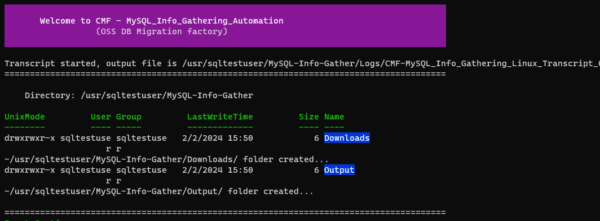
Note: After triggering the automation all the support folders (Logs, Output, Downloads etc.) will be created automatically by the automation script, MySQL path is validated, and it will ask user to proceed with the execution of the script.
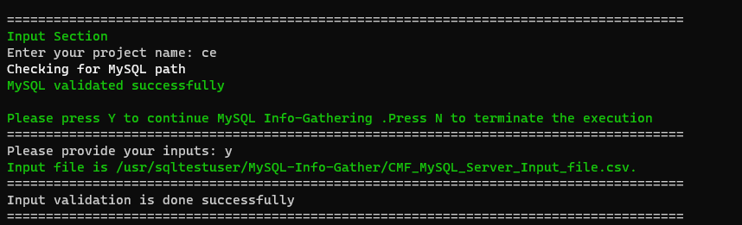
- The script then Validates the list of Hosts to proceed with execution. Continue by Entering “Y” and provide your Project Name. You’ll get below final status of the script execution.
Note: Ensure you add the location of Mysql.exe to your Path environment variables
- List of the Hosts the automation will proceed based on the user selection.
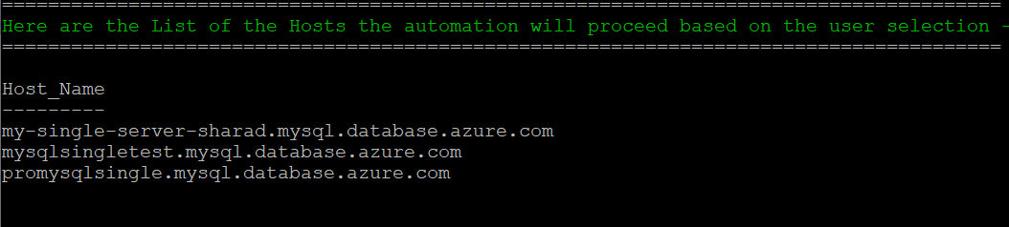
- Next, enter “Y” to proceed MySQL server Info-Gathering.
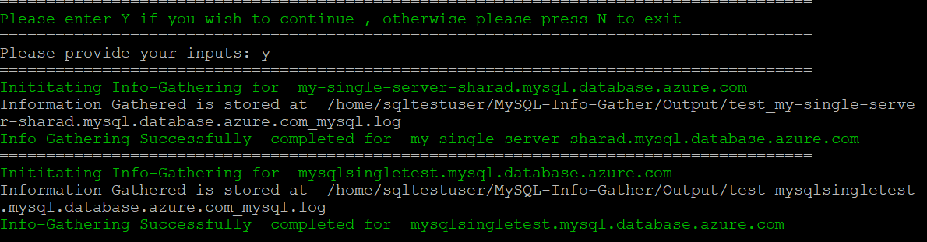
- Check the final status of script execution
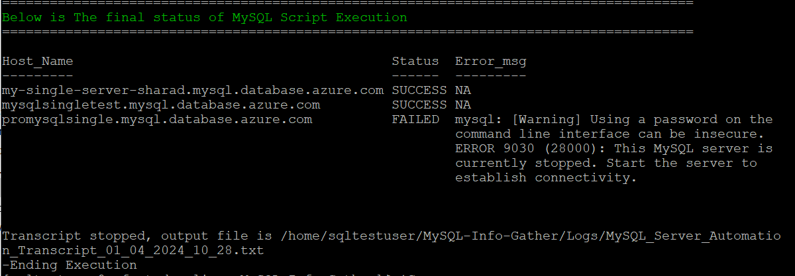

Export Info-Gathering details and generating Output log files
- Output log files are generated for each MySQL Server as shown in the Output Folder below.

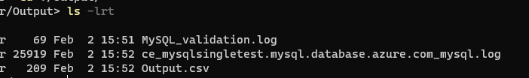

Automation Script Transcript Logs
Note: For the Automation, transcript will be generated in text format as shown above
Note:
- Output files generated using Factory-MySQL-CLI-Windows.ps1 and the log files generated by Factory-MySQL-Windows.ps1 will be in the same Output and Logs folder.
- Please share compressed Output & Logs folder with Factory Team.

MySQL Server Info-Gathering using Azure Cloud Shell
- Click on the icon shown below to open the Azure cloud shell
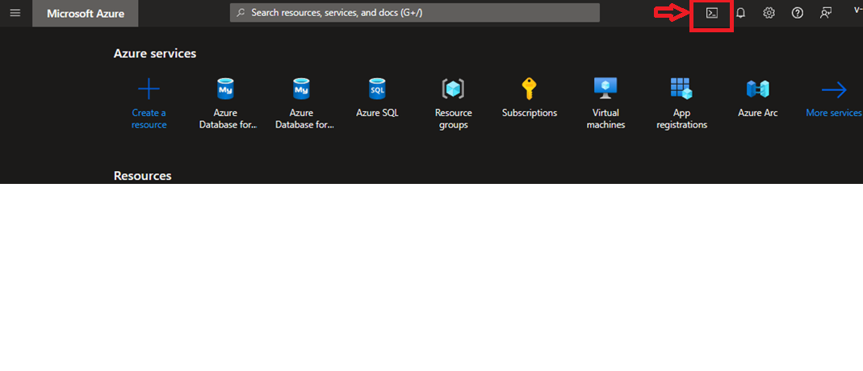
- Click on “Show advanced settings”
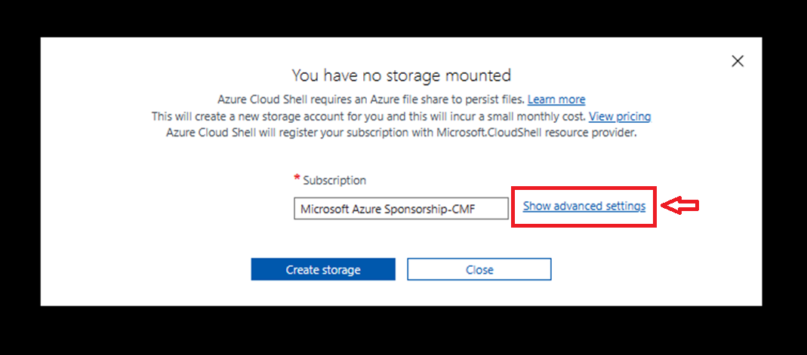
- Choose your preferred region, you can either use existing or create a new resource group for creating the storage account and file share and then click “Create storage”
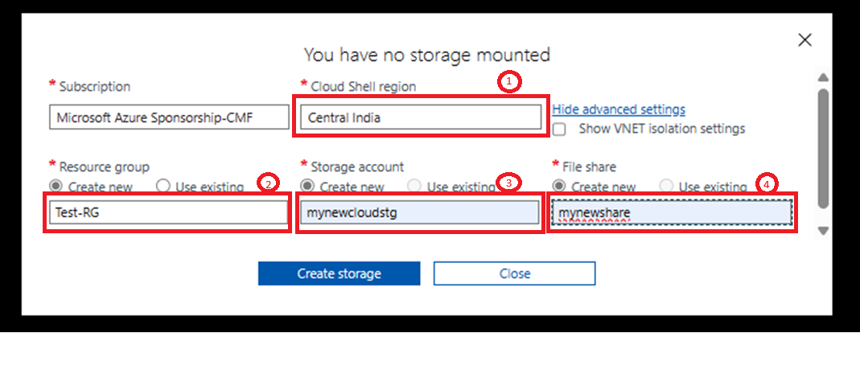

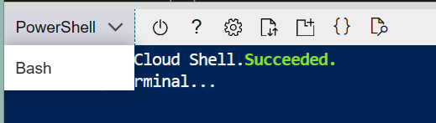
- Choose PowerShell as the Shell.
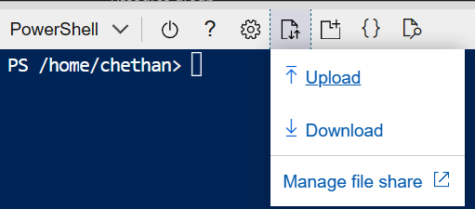
- Upload the MySQL-Info-Gather.zip file.

Scripts Folder
- Unzip the MySQL-Info-Gather zip file received by Factory Team
Commands: unzip MySQL-Info-Gather.zip
ls -lrt
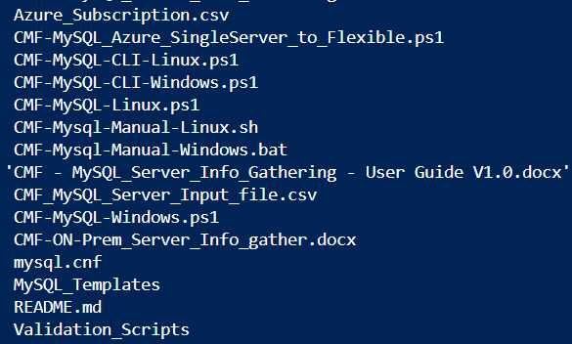

Preparing the INPUT File (Azure_Subscription.csv)
- To support the Info Gathering process, INPUT CSV FILE
(Azure_Subscription.csv) should be provided with appropriate details.
- Open the Cloud Shell editor to edit the csv file.
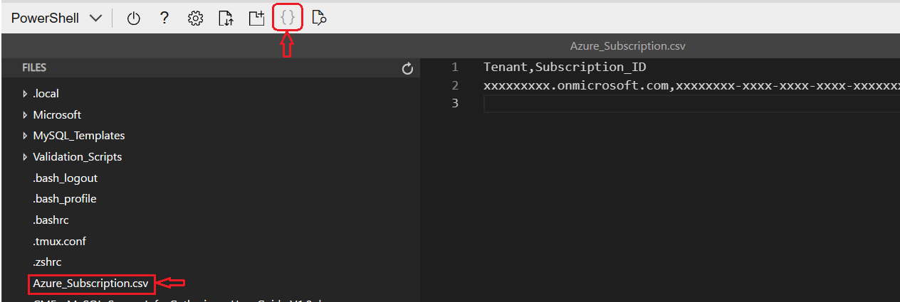

- In Azure_Subscription.csv file, provide the Tenant and Subscription ID.
- Save and close the editor.
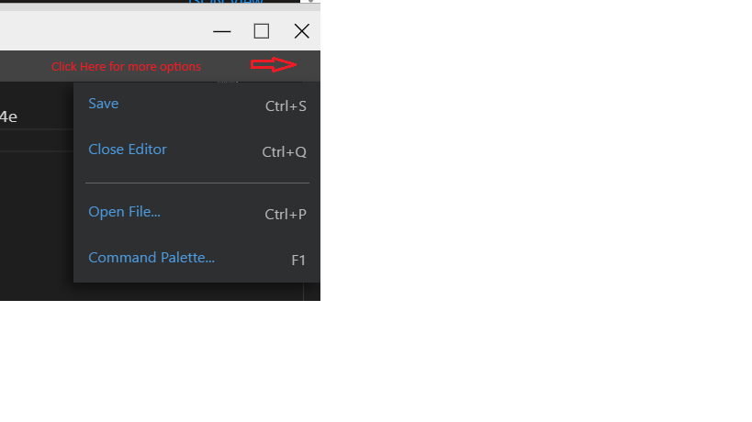

Script execution (Factory-MySQL-CLI-Linux.ps1)
- Enter the following command to execute the script.
./Factory-MySQL-CLI-Linux.ps1
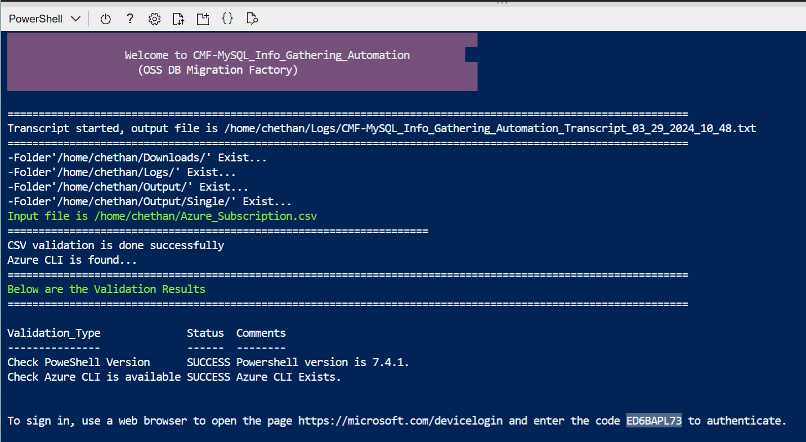
- Copy the device login URL and code to authenticate
- Output is as shown below.
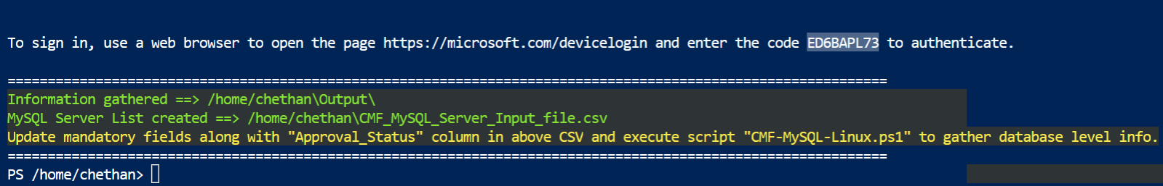
- Open the Cloud Shell editor to edit the Factory-MySQL_Server_Input_file.csv file.
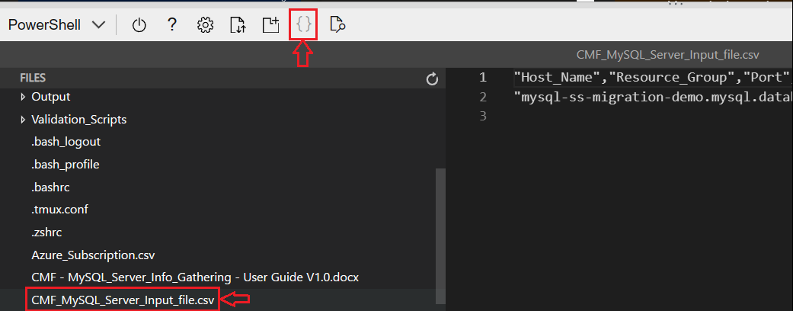
- In Factory-MySQL_Server_Input_file.csv file, provide the password and Approval Status.
Note: Password can also be provided during script execution.
- Save and close the editor.

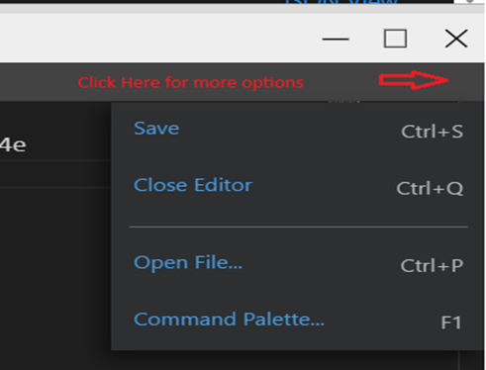
- Run the below script for MySQL Server Info Gathering
./Factory-MySQL-Linux.ps1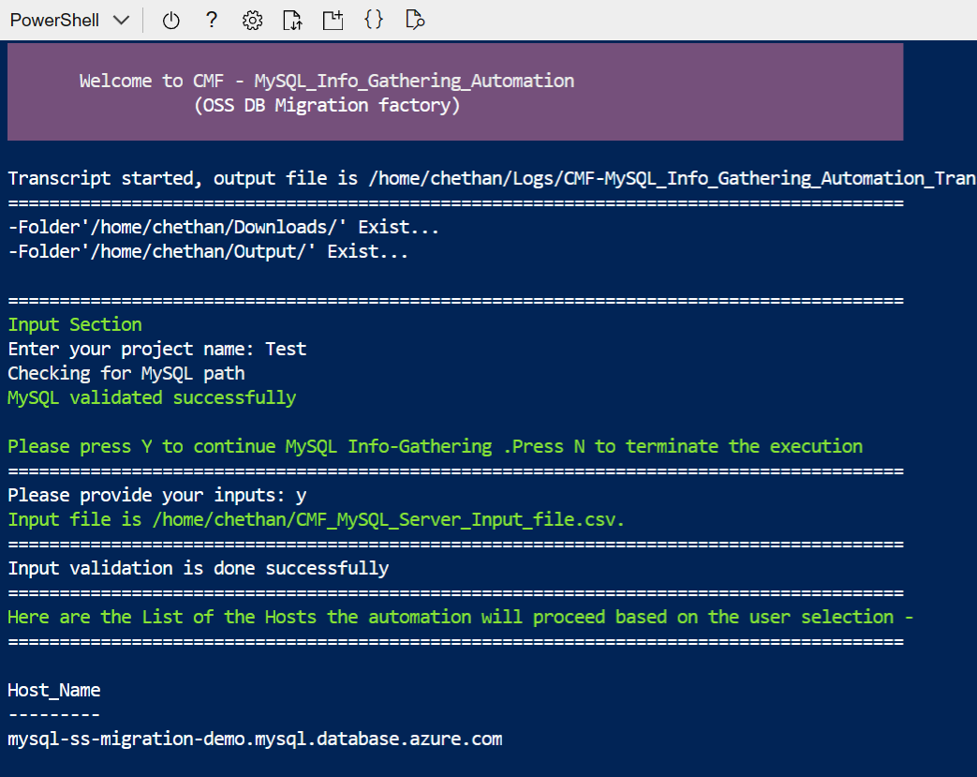
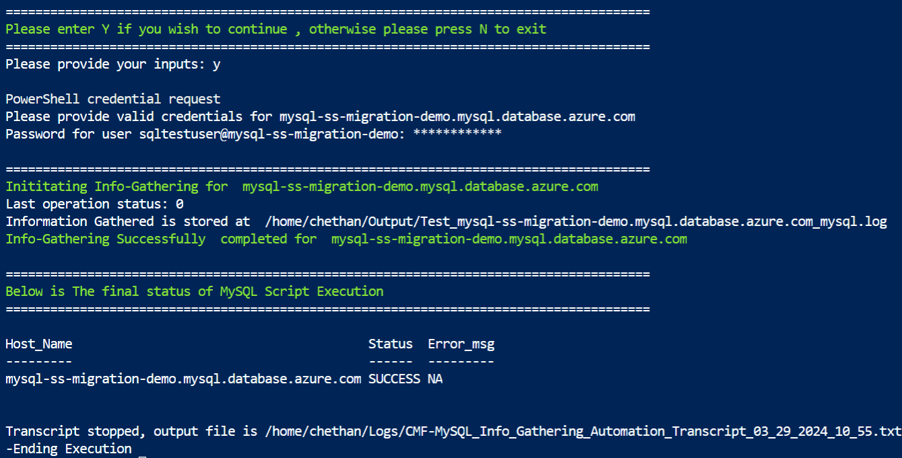
- Zip the Output and Logs folder, download and share it with the Factory Team using the commands below.
zip -r filename.zip ./Output ./Logs
- To download the zip files -
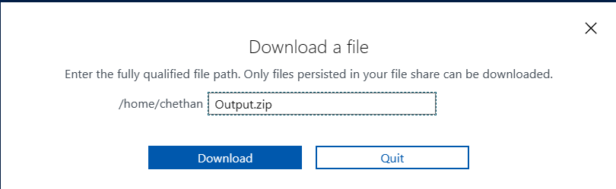
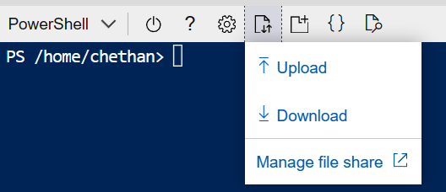

Appendix.

Checking error logs
- If script execution fails due to some errors, check the detailed error log in
Output->folder -> folder mysqlxxx.mysql.database.azure.com.log file.
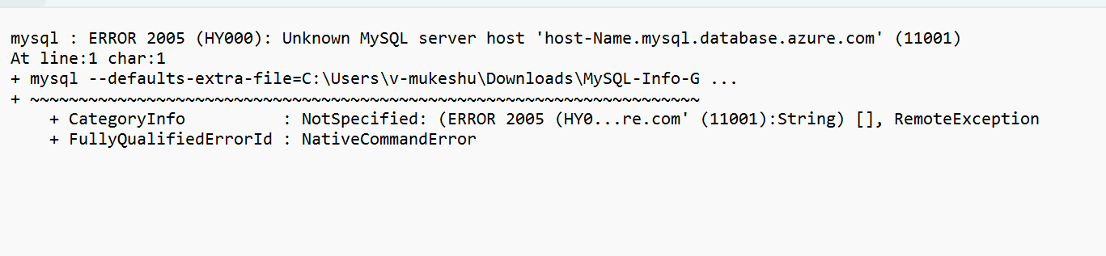

Troubleshooting 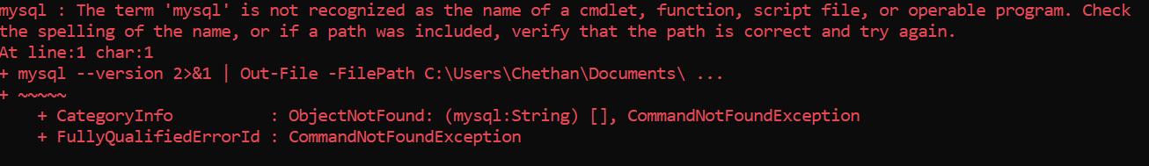
- Add the MySQL server binary path in environment variables. Refer below link for steps.
Adding mysql as an environment variable in Windows

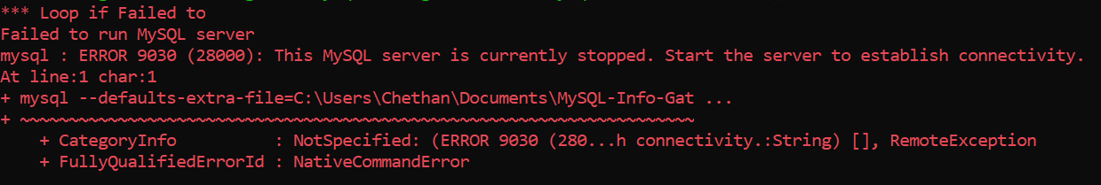
- Ensure the server is up and running and then execute the scripts.

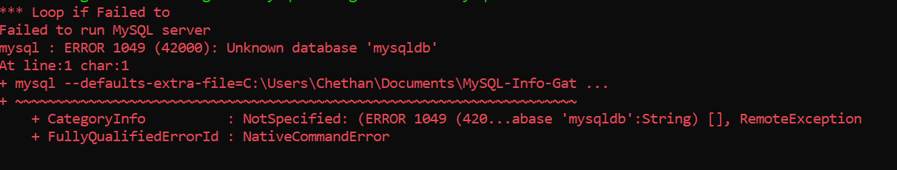

- In the Factory_MySQL_Server_Input_file.csv file, ensure that the “DB_Name” column value is “mysql”.

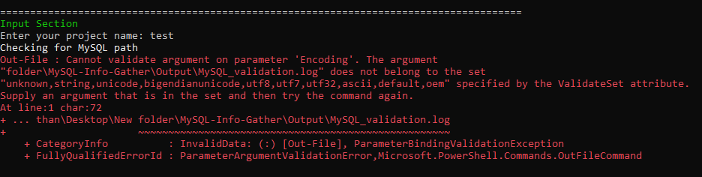
- Ensure that the scripts folder name does not contain any whitespaces. Additionally, in the above example, the scripts folder name is correct but it’s inside the “New folder” which contains a whitespace.

Input CSV file- Azure_Subscription.csv

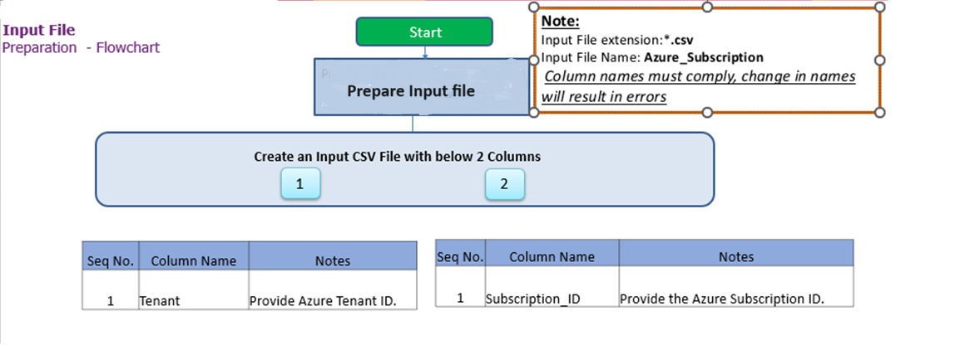
Important Notes:
- This script is based on the csv file named ‘Azure_Subscription’ and the following columns in the Input csv file
- INPUT CSV FILE name must be Azure_Subscription.csv
- Column Name must be kept as shown below, change in names will result in errors.
- Values in the column must be correct, incorrect values will also result in error
Seq.No | File | Note
1 | 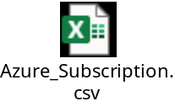 | Sample: Azure_Subscription.csv

Input CSV file - Factory-MySQL_Server_Input_file.csv
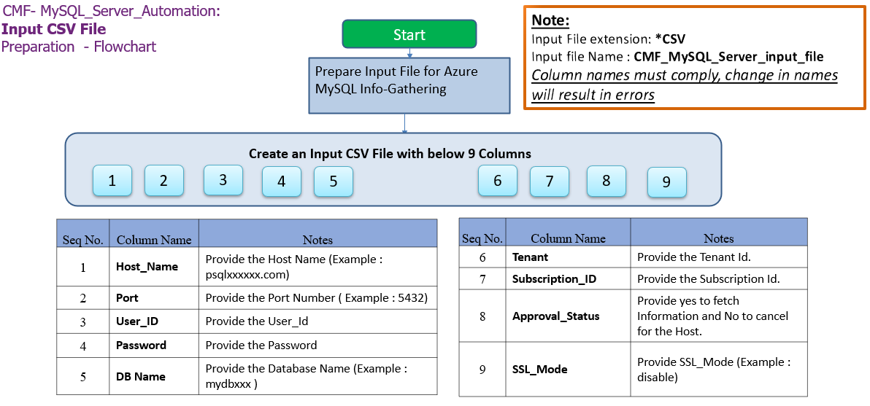

Important Notes:
- MySQL Client is required to establish Connectivity to MySQL Servers.
- This script is based on the CSV file named ‘Factory-MySQL_Server_Input_file.csv’.
- Column Name must be kept as shown below, change in names will result in errors.
- Values in the column must be correct, incorrect values will also result in errors.
- Tenant and Subscription_ID columns are Optional.
- Password field is optional but should be provided during script execution if omitted.

- Columns for Input File: Factory-MySQL_Server_Input_file.csv
Column Name | Note
Host_Name | Provide Host Name (Example: localhost)
Port | Provide Port Number (Example: 3306)
User_ID | Provide the User_ID
Password | Provide the Password
DB_Name | Provide Database Name (Example:mysql)
Tenant | Azure Subscription tenant ID (Optional)
Subscription_ID | Azure Subscription ID (Optional)
Approval Status | Provide YES to fetch the information and NO to exclude the host.
SSL_Mode | Provide SSL_Mode (Example : preferred)

Seq.No | File | Note
1 | 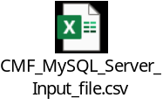 | Sample:  Factory-MySQL_Server_Input_file.csv

Internet access to the URLs below:
URL | Note
https://aka.ms/installazurecliwindows | Azure CLI
https://learn.microsoft.com/en-us/cli/azure/install-azure-cli-linux?pivots=dnf | Azure CLI (Linux)
https://aka.ms/PSWindows | PowerShell (Windows)

Without Internet access to the URLs
Follow the instructions in the following sections to download all the software manually to a server where internet connectivity is enabled. Once all the software is downloaded, move all of it to the server where MySQL Automation script will be executed and install all of them one by one.

Installing Azure CLI for Windows and Linux
Windows - https://aka.ms/installazurecliwindows
Linux - https://learn.microsoft.com/en-us/cli/azure/install-azure-cli-linux

PowerShell Version, Modules & Execution policy
Execute the below commands from windows PowerShell as Administrator.
- To find the PowerShell Version
- Get-Host
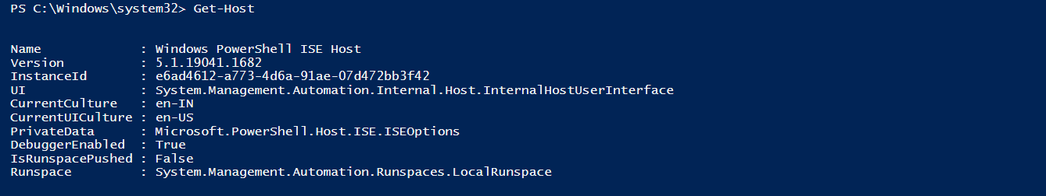
- Set the PowerShell execution policy
- Set-ExecutionPolicy Unrestricted -Scope CurrentUser

PowerShell Installation on Linux
- Register the Microsoft RedHat Repository

curl https://packages.microsoft.com/config/rhel/7/prod.repo | sudo tee /etc/yum.repos.d/microsoft.repo

- Install PowerShell

sudo yum install –assume yes powershell

- Start PowerShell

Pwsh

Adding mysql as an environment variable in Windows
- To add the MySQL Client to your environment path, you'll need to modify the system's PATH environment variable to include the directory where the MySQL Client is located. Below are the steps to add the mysql client to the system env path,

- After the installation, open Start menu, search for Environment variables and select “Edit the system Environment variables”

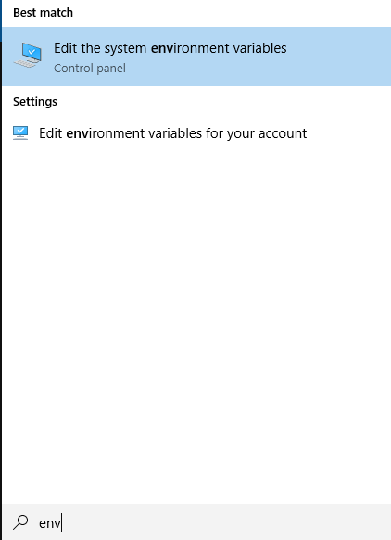

- In the System Properties window, click the “Environment variables”

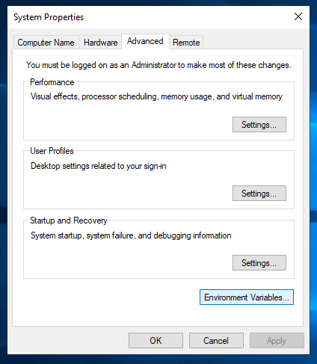
- Next, in the Environment variables window, under “System variables” section, select Path and click “Edit”

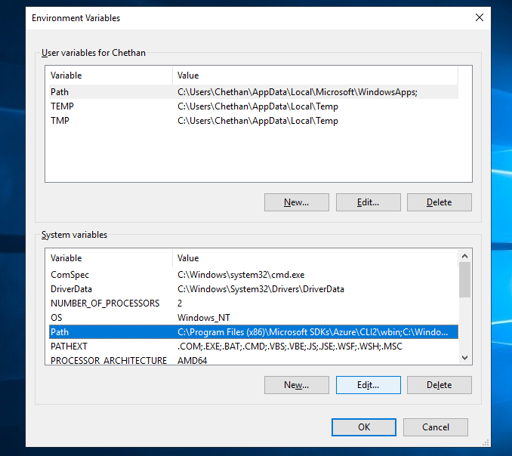

- Click the “New” button and add the installation path or Browse to navigate and add the MySQL Client installation directory path (e.g. C:\Program Files\MySQL\MySQL Server 8.0\bin or the path where MySQL Client is installed) as shown below

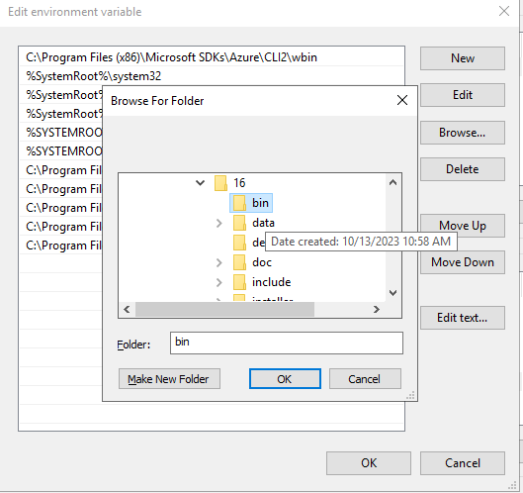
- Click “OK” to close each window.

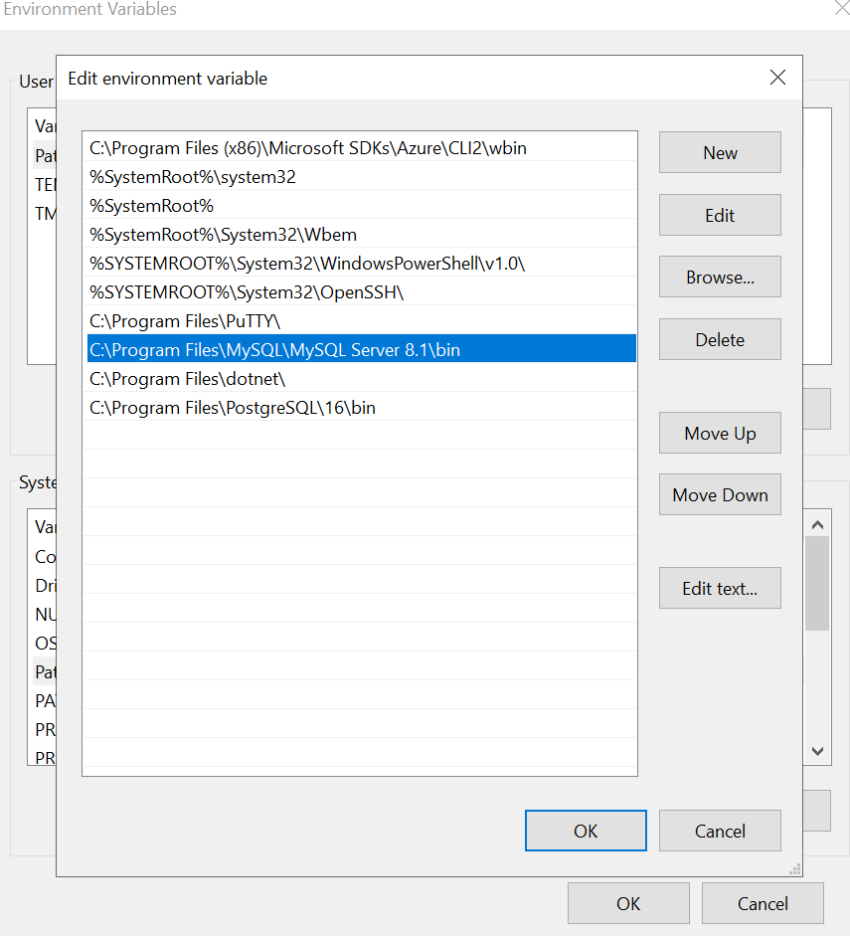
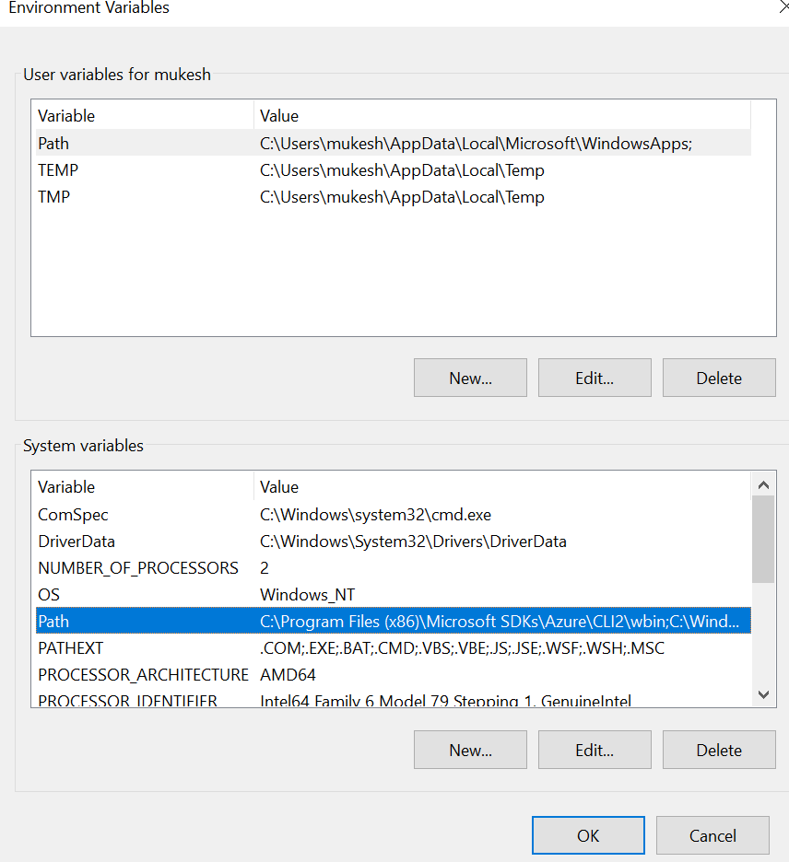

Adding Azure CLI as an environment variable in Windows
- To add the Azure CLI to your environment path, follow the steps below,

- After installation, open the Start menu, search for "Environment Variables," and select "Edit the system environment variables."

- In the System Properties window, click the "Environment Variables" button.

- In the Environment Variables window, under the "System variables" section, find and select the "Path" variable, then click the "Edit" button.

- Click the "New" button and add the path to the Azure CLI installation directory (e.g., C:\Program Files\Microsoft SDKs\Azure\CLI2\wbin).

- Click "OK" to close each window.

- Verify by opening a new Command Prompt or PowerShell window and type “az” to verify that the Azure CLI is now accessible.

